Increasing diversity and inclusivity in the Biosciences

Equality, diversity and inclusivity apply to all. Whilst much progress has been made over the last decades, there is still work to do to ensure that the Biosciences is a welcoming and sustainable career choice for all. At university level, we need to ensure that academics are aware of the individual needs, challenges and situations of our students to enable them to succeed. In this project, we wanted to co-create resources with our students to do this, and the focus on developing empathy in our academics, so that they were empowered to better understand students no matter what their background or situation. Students report that a challenge in their success is that there are not always academics “like them”; whilst we cannot change anyone’s race, for example, we can develop the ability to empathise with, and understand, people in different situations.
Co-creation is accepted to be a valuable tool within HE. Importantly, here, we wanted the students to direct the resources available to academics. We do not always know what we do not know about others and this gives a valuable opportunity for students from a variety of backgrounds to develop resources to ensure that academics are better informed. After discussing our thoughts with students through group sessions and individual meetings, they suggested creating a suite of resources based on their experiences to give to staff; we deliberately used a variety of fora to ensure as wide a participation as possible. During their final year research projects, a number of students created such resources based on their personal situations ranging from hidden disabilities to practising Islam. The resources created were a combination of recorded presentations, ‘a day in the life of…’ videos, and fact files, all hosted on our Blackboard Virtual Learning Environment (VLE) in our Staff Training Module. Staff undertook a quick knowledge assessment before using the resources and afterwards, with all demonstrating an increased knowledge of the areas and appreciation of the particular challenges after the training. We will continue to build on these resources over the coming years.

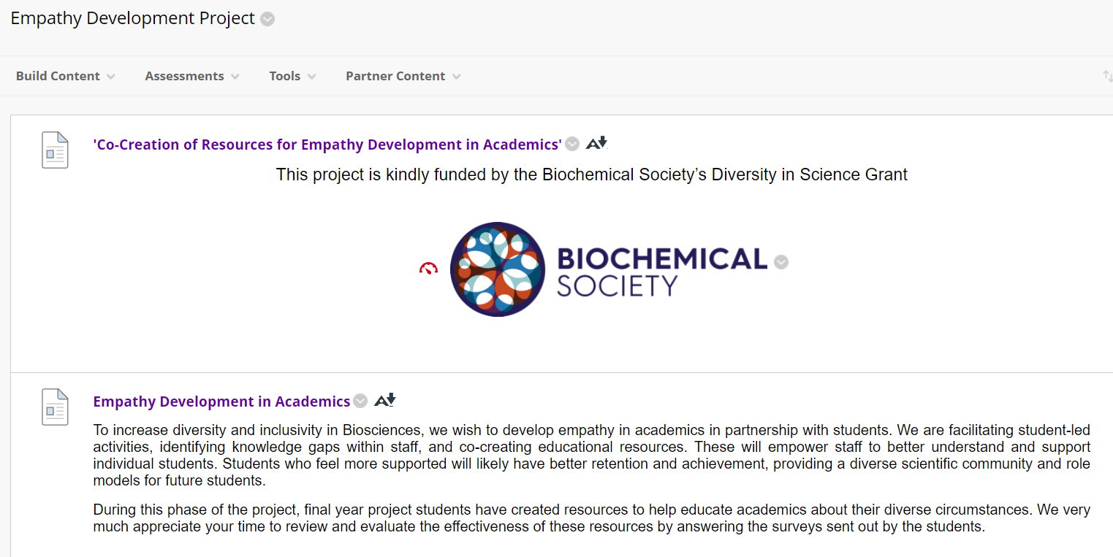
Figure 1: The landing page for the Empathy Development Project on our VLE.
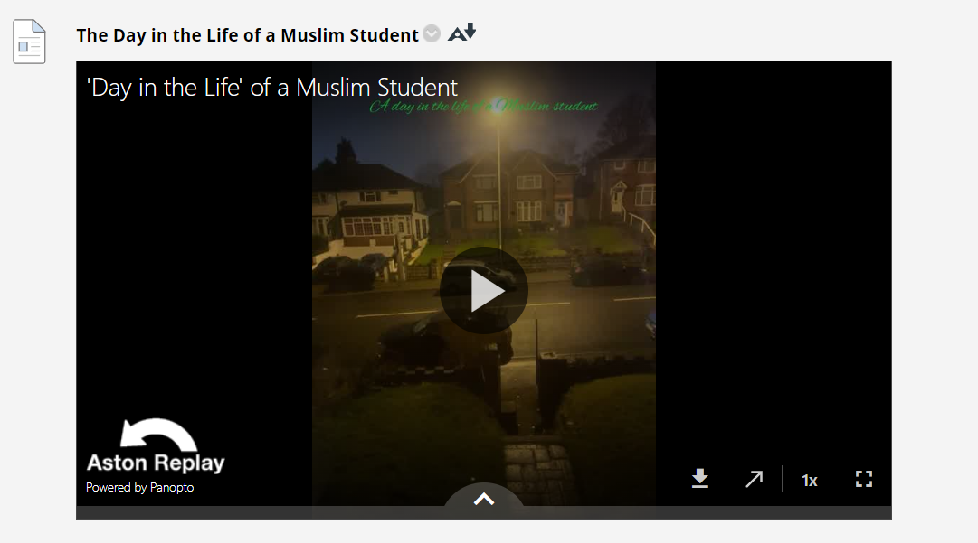
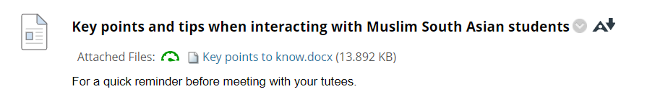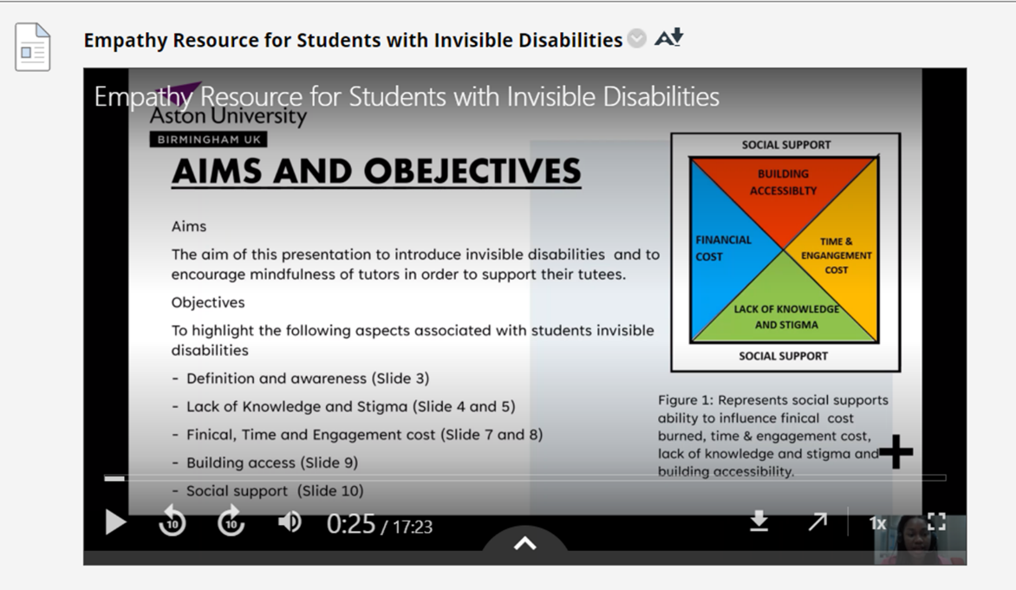
Figure 2: Screenshots of some of our student-created training resources hosted on our VLE.

In addition to the training resources, we want to ensure that staff develop their all-round empathy skills. As such, we have been further enhancing our Empathy Development Toolkit, first conceptualised by Jo Gough as part of her MEd research. This is a suite of resources, of varying depth, to increase positive staff-student actions. We have developed a cue-card that all staff can use before their meetings with students with a four-step process of “Ls” – Let go, Learn, Listen and Lay down next steps. This process is designed to allow staff to focus on that particular meeting, to use our resources to increase their knowledge, to actively listen and then to act on this new knowledge in a practical way, e.g., signposting to other professional services.
Through a combination of our new staff training resources and our Empathy Development Toolkit, we envisage that this will lead to more successful academic-student interactions and, consequently, increased engagement and achievement of students in an academic setting. Success at degree level often correlates with careers in science – higher achieving students will go on to further study and research careers. Importantly, though, even those students who choose not to stay in science will have a more positive view of their university experience and will hopefully encourage their younger peers to undertake study in the sciences. By fostering an inclusive community, we aim to show that science is for all, thereby naturally increasing the diversity of scientists.

